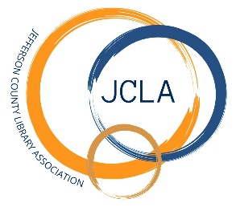**JOINT MEETING**

**JCLD/JCLA BOARDS OF DIRECTORS**

**Tuesday, January 7, 2025 @ 5:30 pm**

**241 SE 7th St, Madras, OR 97741**

**Agenda**

1. **Call to Order**
2. **Public Comment**
3. **New Business:** Building Expansion Project
4. **Adjourn**